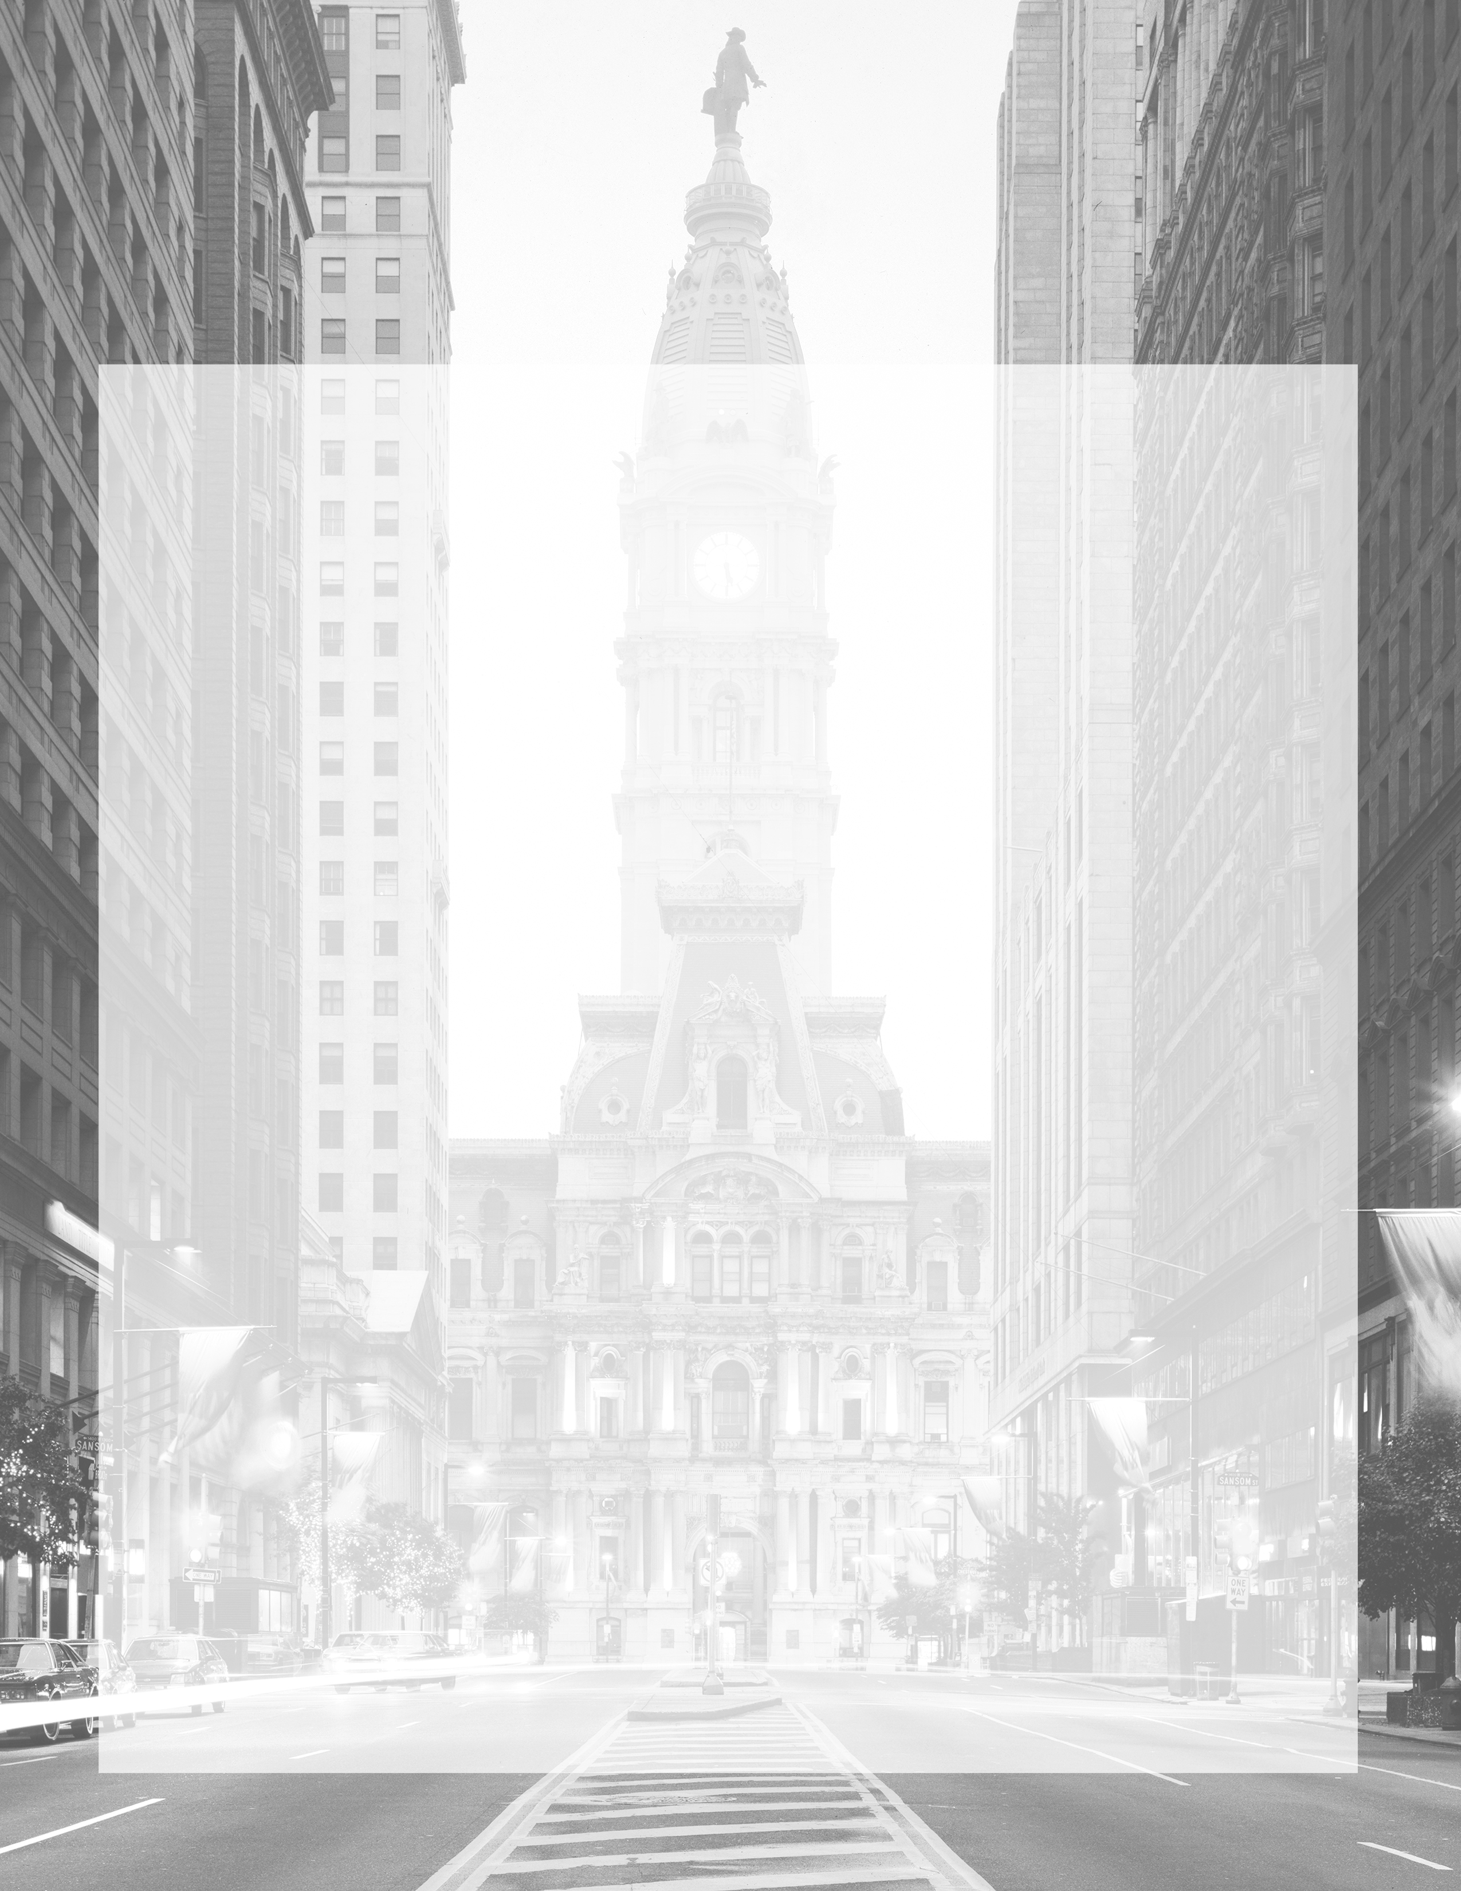

**Frequently Asked 2016 Convention Questions**

**HOTELS**

**Where will my hotel be located?**

**A:** The hotel allotments have not been distributed at this time. More information will be provided when it becomes available.

**Can I request specific hotels?**

**A:** No. Staff will assign hotels based on availability and the package level you qualify for.

**Is my hotel within walking distance of the Convention proceedings?**

**A:** Hotel allotments will not be distributed until more information becomes available. If your hotel is not within walking distance of the convention proceedings there are multiple options for transportation for guests.

**Do I need to stay at the hotel I am assigned the minimum number of nights required or is that flexible with my travel plans?**

**A:** Yes. Minimum nights of stay at hotels must be adhered to and payments for the minimum amount of nights must be fulfilled to guarantee room.

**TRANSPORTATION**

**Will transportation be provided during the week for convention activities?**

**A:** No. Philadelphia will have multiple forms of mass transportation for convention guests. At this time no additional transportation is planning on being provided throughout the week by the DCCC.

**Can I bring a driver?**

**A:** Yes. You can bring a driver. Security restrictions and traffic patterns will still apply for all individuals. Currently specific restrictions have not yet been disclosed.

Paid for by the Democratic Congressional Campaign Committee.

430 South Capitol Street, SE • Washington, DC 20003 • (202) 863-1500 • [www.dccc.org](http://www.dccc.org)

Not authorized by any candidate or candidate’s committee





**CREDENTIALS**

**When will I know what credentials I receive?**

**A:** Credential information will not be provided until more information is made available to us.

**Can I request certain credentials based on what I qualify for in my package?**

**A:** Yes. You may request certain credentials but there are no guarantees on what you will receive.

**Can I request extra event tickets?**

**A:** Yes. You may request additional tickets to DCCC events. All requests will be subject to availability.

Paid for by the Democratic Congressional Campaign Committee.

430 South Capitol Street, SE • Washington, DC 20003 • (202) 863-1500 • [www.dccc.org](http://www.dccc.org)

Not authorized by any candidate or candidate’s committee